1 INTRODUCTION

* 1. Overview
* Select a template
* Customize your infographic
* Perfect your design with elements
* Save and share.
  1. Purpose
* Choose an infographic template for your specific need
* Upload your text
* Customize your infographic with charts
* Scan your design for final proofing.

1. problem definition &design thinking
   1. Empathy map

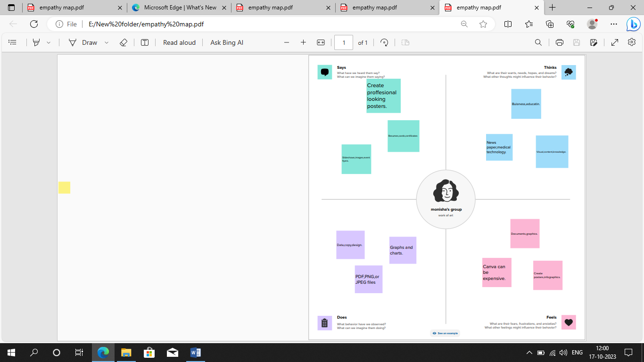

2.1 Brain stroming

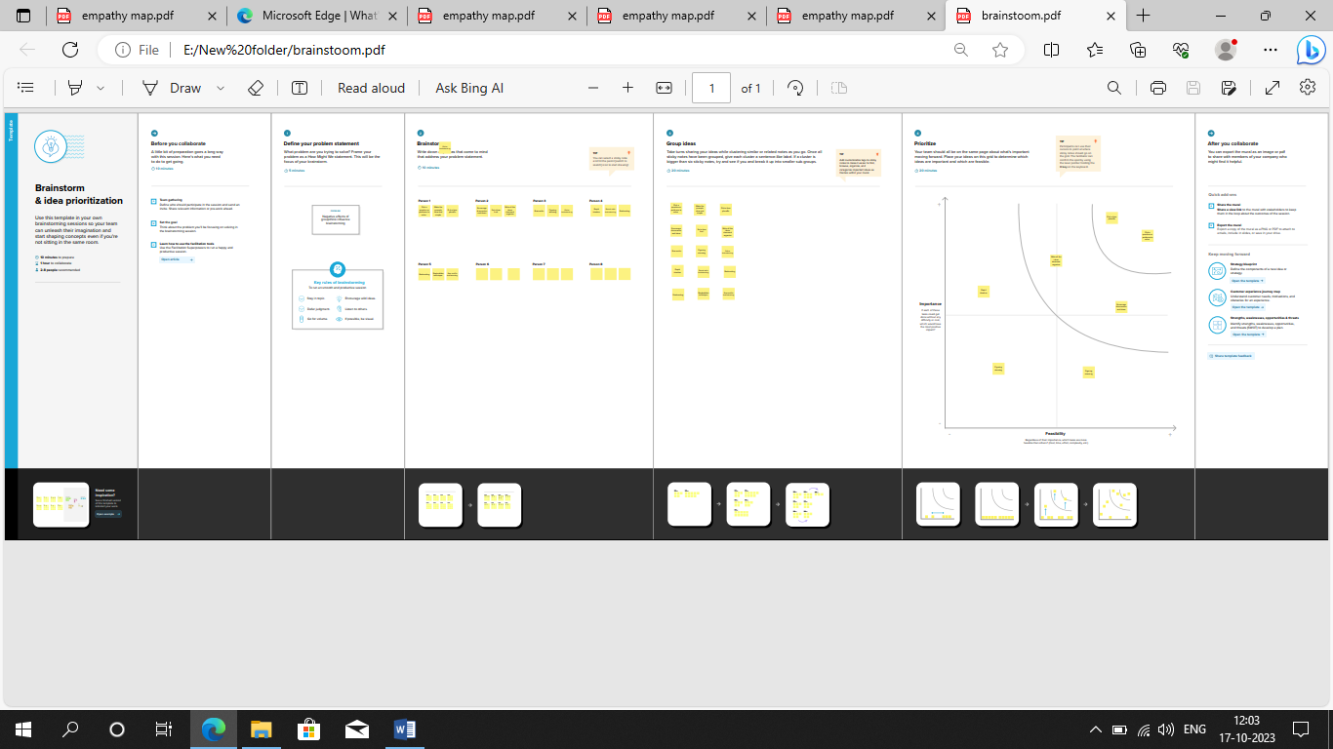

**3.Result**

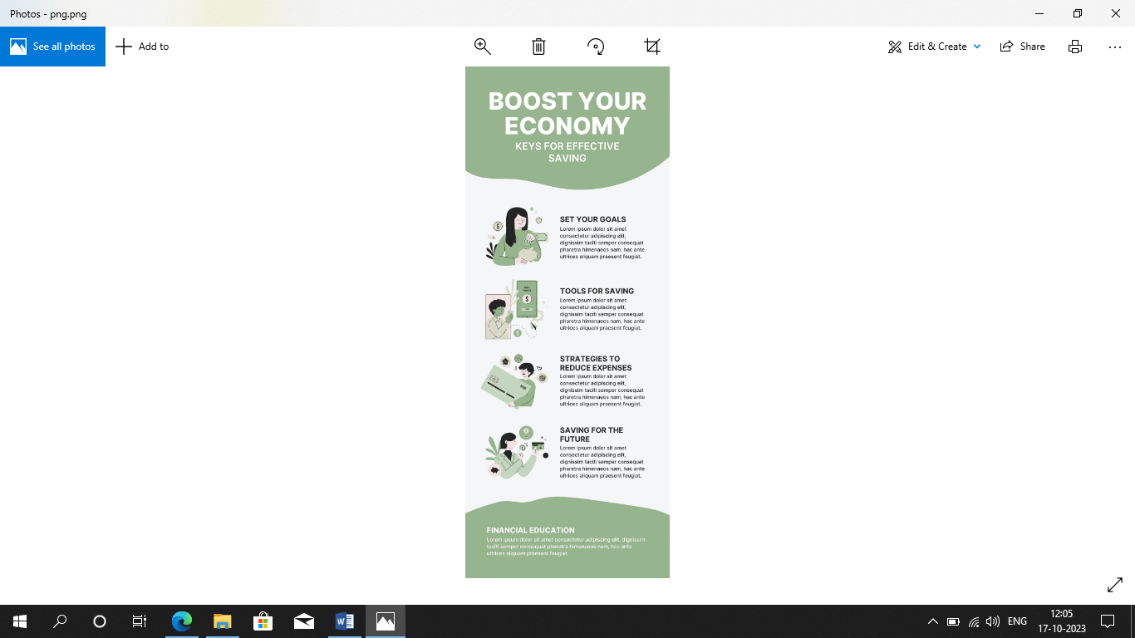

**4.Advantages&Dis advantages**

**Advantages**

* *Canva style*
* *Alignment concerns*
* *Export settings are limited*
* *The free version is limited***.**

**Disadvantages**

* *Easy to use*
* *Low flexibility*
* *Bloated coding*
* *Your budget*

**5 Application**

*Some of the best infographics tools and infographics maker soft ware are visme venngage , canva and pikto chart .In this comparison guide for 2023, we compare these and many more infogrphic tools to help you choose the best infograph maker for your business.*

**6 conclusion**

*A good conclusion essentially looks like a triangle, which is the opposite of an introduction. We start with the specific and move in to the general. Don’t simply repeat what you’ve already stated in your paper,*  *demonstrate how they fit together.*